AML TRANSACTION
AND FRAUD ANALYSIS
Interactive Dashboard Report using Microsoft Power BI

Submitted by
Niveditha Aanand
Roll No: E25FA059
B.Com FinTech with AI
2nd Year

Dataset: IBM – Anti-Money Laundering

1. Project Overview
Money laundering and suspicious financial activity can be difficult to identify when transaction records are viewed one by one. This project uses the IBM Anti-Money Laundering dataset in Microsoft Power BI to organise transaction and alert information into a visual dashboard. The report provides a quick view of transaction activity, fraud labels, account coverage, transaction values and alert categories.
Instead of reading long lists of records, a user can compare patterns through charts and KPI cards. The dashboard is intended to support initial review and help identify areas that may need closer investigation. A visual flag or alert is an indicator for review, not proof that a person or transaction is involved in a crime.

2. Purpose and Project Objectives
The main purpose is to make transaction-monitoring information easier to understand and explore. The dashboard was designed to:
- Present the overall transaction count, transaction value and number of accounts.
- Show how transactions are divided between the False and True fraud-status labels.
- Observe how transaction volume changes across the displayed timestamps.
- Compare the timestamp pattern for transactions marked as fraudulent.
- Review the total transaction amount for each fraud-status category.
- Compare the number of alerts recorded under cycle and fan_in.
- Use slicers and a tooltip page to inspect selected data without crowding the main report.

3. Dataset and Fields
The report uses the Transactions and Alerts tables visible in the Power BI model. The fields shown in the project include TX_ID, TX_AMOUNT, TIMESTAMP, IS_FRAUD, TX_TYPE, sender and receiver account details, ALERT_ID and ALERT_TYPE. These fields connect transaction activity with fraud labels and alert information.
The summary cards display four key measures: total transactions, total transaction amount, total accounts and fraudulent transactions. The screenshots show rounded or shortened values in some cards, so the report uses approximate values where the full figure is not visible.

4. Data Preparation and Report Setup
Before interpreting the charts, the data should be checked to ensure that transaction amounts are numeric, timestamps are correctly ordered, fraud labels are consistently recorded and the Transactions and Alerts tables are related appropriately. These checks are important because an incorrect data type or relationship can affect totals and visual comparisons.
The screenshots show the completed dashboard and its visuals; they do not confirm every cleaning step or transformation carried out before the report was built. Therefore, this section describes the checks relevant to the model rather than claiming that every step was completed.

5. Dashboard at a Glance
The main report page brings together several views: a line chart for transaction volume, a donut chart for fraud status, KPI cards, a line chart for fraudulent transaction volume, a bar chart for alert types, a column chart for transaction value by fraud status, and two slicers.
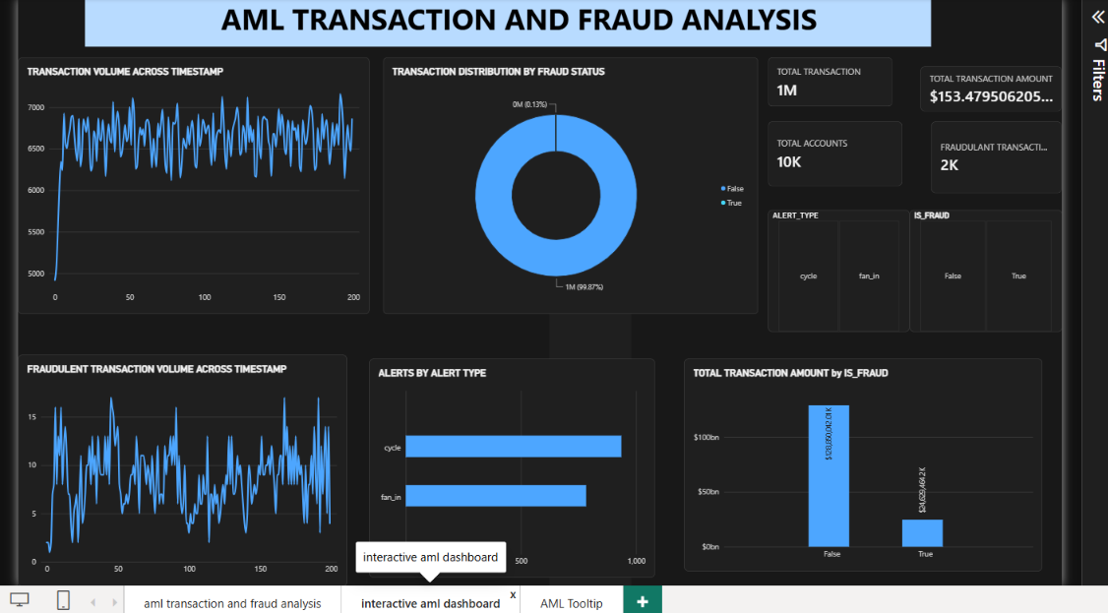
The dark dashboard theme and blue chart colours make the visuals easy to distinguish. Keeping the summary cards near the top allows a viewer to understand the overall scale before examining individual patterns.

6. Key Performance Indicators

6.1 Overall transaction count
The total transaction card displays approximately 1 million records. This gives a sense of the size of the dataset being reviewed.

6.2 Transaction amount
The total transaction amount card shows about $153.48 billion. The displayed figure is truncated in the screenshot, so the amount is presented as an approximate value.

6.3 Accounts covered
The account KPI displays approximately 10,000 accounts, providing a broad view of the account coverage represented in the report.

6.4 Transactions marked as fraudulent
The fraud KPI shows around 2,000 transactions. This value is a summary of records marked True in the fraud-status field and should be interpreted according to the dataset's labelling.
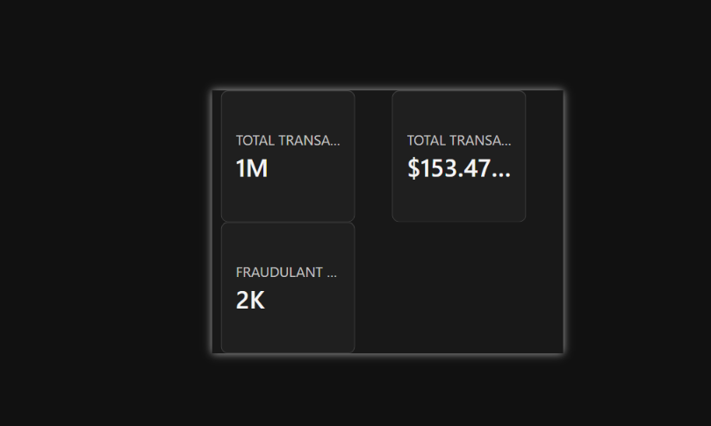

7. Fraud-Status Distribution
The donut chart compares transactions labelled False and True in the IS_FRAUD field. The screenshot reports approximately 99.87% as False and 0.13% as True. The True segment is very small in comparison with the overall transaction volume.
This difference shows that records marked as fraudulent make up a small share of the dataset. However, the small proportion does not mean those records can be ignored. They may require review because of their potential significance.
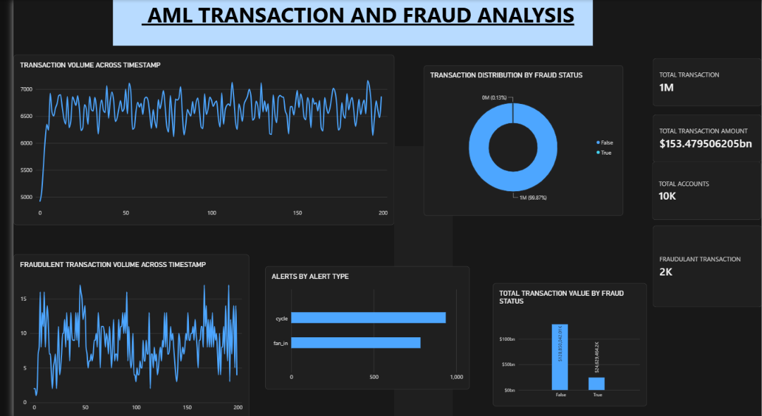

8. Transaction Volume Over Time
The transaction-volume line chart begins with a sharp rise from a lower starting point. After this initial movement, the values fluctuate mostly between about 6,200 and 7,100 across the displayed timestamp sequence. Repeated peaks and dips suggest that transaction activity varies over the period rather than remaining completely steady.
A reviewer could use this view to identify timestamps with unusually high or low activity and then examine the related records. The chart alone does not explain why the changes occurred; additional transaction details would be needed to establish a cause.

9. Fraudulent Transaction Volume Over Time
The second line chart isolates transactions classified as fraudulent. The displayed values move unevenly, often ranging from around 2 to 15, with a few spikes above 15. This indicates that the number of flagged transactions changes across timestamps.
Periods with higher values may be useful starting points for further analysis. They should be checked against transaction type, account information and other available evidence before deciding whether a genuine fraud pattern exists.

10. Transaction Amount by Fraud Status
The column chart compares the monetary value associated with the False and True categories. The False category forms the much larger column, while the True category is visibly smaller. This is consistent with the distribution chart, where the False category represents nearly all transactions.
The chart provides a comparison of recorded transaction amounts, but it does not directly measure confirmed financial loss. To estimate losses, the flagged records would need to be verified and assessed separately.

11. Alerts by Alert Type
The horizontal bar chart includes two alert types: cycle and fan_in. The cycle bar is longer, at roughly 900–950 alerts, while fan_in is around 750–800. Within the displayed data, cycle alerts are therefore more frequent.
An alert identifies activity selected for attention by the monitoring process. It should be treated as a lead for review rather than a final conclusion that fraud has occurred.

12. Interactive Slicers and AML Tooltip

12.1 Slicers
Two slicers are visible in the interactive report: ALERT_TYPE, with cycle and fan_in options, and IS_FRAUD, with False and True options. Selecting a category allows the user to focus on a subset of the report and compare the related charts.

12.2 AML Tooltip page
The report also contains an AML Tooltip page intended to display extra summary information when a user explores a visual. In the supplied screenshot, the tooltip shows approximately 6K transactions and 8 fraudulent transactions. The transaction-amount value begins with $288.3, but the rest is cut off, so the full amount cannot be confirmed.
The tooltip gives additional context without placing every measure on the main dashboard. This can make the report easier to read while still allowing a user to inspect more detail.

13. Main Observations
- The dashboard summarises approximately 1 million transactions across about 10,000 accounts.
- Around 2,000 transactions are displayed as fraudulent in the summary KPI.
- The donut chart shows a strong imbalance between the False label (about 99.87%) and the True label (about 0.13%).
- Transaction volume rises quickly at the start and then fluctuates within a relatively narrow band across the displayed timestamps.
- Fraudulent transaction counts are less even and include several noticeable peaks.
- The total transaction amount shown for False is much higher than the amount for True.
- Cycle alerts appear more frequently than fan_in alerts in the alert-type chart.
- Slicers and the tooltip page allow users to explore selected categories and view extra summary values.

14. How the Dashboard Can Support AML Review
The dashboard can help a reviewer prioritise areas for further examination. For example, timestamp peaks can be checked for unusual activity, fraud-status filters can isolate records labelled True, and alert-type comparisons can show which category appears more often. The transaction-value chart adds a monetary perspective to the count-based visuals.
For practical use, the findings should be followed by a closer check of individual records, account links, transaction types and the reason an alert was generated. The report supports monitoring and exploration; it does not independently confirm suspicious intent or establish that money laundering has occurred.

15. Conclusion
This project demonstrates how Microsoft Power BI can turn transaction and alert data into a dashboard that is easier to explore. KPI cards give a quick overview, while line, donut, bar and column charts show changes over time and differences between categories. The slicers and AML Tooltip page add another level of interaction.
The main patterns in the screenshots are the very small share of records marked True, fluctuating transaction activity, uneven fraudulent-transaction counts and a higher count of cycle alerts than fan_in alerts. These observations can guide further investigation, but final decisions should be based on verified transaction-level evidence and the appropriate review process.

References
- IBM – Anti-Money Laundering dataset (Dataset 5).
- Microsoft Power BI Desktop.
- Microsoft Power BI documentation.

